|  |
| --- |
| **Edward Tunstel, Jr.** John Hopkins University Applied Physics Laboratory  Senior Robotics |

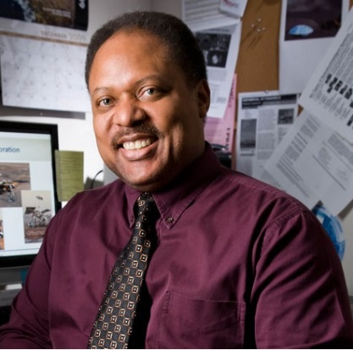

Dr. Edward Tunstel is a senior roboticist in the Research & Exploratory Development Department of JHU/APL. He has served as space robotics & autonomous control lead in the Space Department. He joined JHU/APL in 2007 after 18 years at NASA JPL, where he was a senior robotics engineer and group leader of its Advanced Robotic Controls Group. He earned his bachelor's and master's degrees in mechanical engineering from Howard University and his PhD in electrical engineering from the University of New Mexico. Dr. Tunstel maintains expertise in robotics and intelligent systems with current research interests in mobile robot navigation, autonomous control, cooperative robotics, robotic systems engineering and soft computing applications to autonomous systems. He has authored over 130 technical publications and co-edited four books in these areas. He worked on the NASA Mars Exploration Rovers mission as both a flight systems engineer responsible for autonomous surface navigation and as rover engineering team lead for the mobility and robotic arm subsystems. He was involved in the daily performance assessment, planning, and operations of the Spirit and opportunity rovers during their first four years on Mars. He is now engaged in modular open systems development efforts supporting the Navy's Advanced EOD Robotic Systems program, as well as robotics and autonomy research for future national security and space applications. Dr. Tunstel is an IEEE Fellow and a member of AIAA and NSBE-Alumni Extension.

|  |
| --- |
| **Garry Roedler** Lockheed Martin Fellow Engineering Outreach Program Manager Lockheed Martin Corporation |

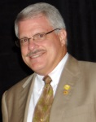

 Garry Roedler is a Fellow and the Engineering Outreach Program Manager for Lockheed Martin.  His systems engineering experience spans the full life cycle and includes technical leadership roles in both programs and systems engineering business functions. Garry holds degrees in mathematics education and mechanical engineering from Temple University and the Expert Systems Engineering Professional (ESEP) certification from INCOSE. Garry is an INCOSE Fellow, author of numerous publications and presentations, and the recipient of many awards, including the INCOSE Founders Award, Best SE Journal Article, IEEE Golden Core, Lockheed Martin Technical Leadership Award and Lockheed Martin NOVA Award.  His leadership roles across many technical organizations include Chair of the INCOSE Corporate Advisory Board, steering group member for the National Defense Industrial Association Systems Engineering Division, working group chair for the IEEE Joint Working Group for DoD Systems Engineering Standardization, editor of ISO/IEC/IEEE 15288, Systems Life Cycle Processes and several other standards, and key roles in the development of the Systems Engineering Body of Knowledge (SEBoK) and the INCOSE Systems Engineering Handbook.  This unique set of roles has enabled Garry to influence the technical co-evolution and consistency of these key resources.

|  |
| --- |
| **Roberto Horowitz** James Fife Endowed Chair,  Director, Partners for Advanced  Transportation Technology (PATH)  Professor of Mechanical Engineering University of California, Berkeley |

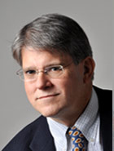

Roberto Horowitz (SM’89) received the B.S. degree (Hons.) in 1978 and the Ph.D. degree in mechanical engineering in 1983 from the University of California, Berkeley. In 1982 he joined the Department of Mechanical Engineering, University of California, Berkeley, where he is currently a Professor and the James Fife Endowed Chair. His research interests include the areas of adaptive, learning, nonlinear and optimal control, with applications to microelectromechanical systems (MEMS), computer disk file systems, robotics, mechatronics, and intelligent vehicle and highway systems (IVHS). Dr. Horowitz is a fellow of the American Society of Mechanical Engineers. He is the recipient of the 2010 ASME Dynamic Systems and Control Division (DSCD) Henry M. Paynter Outstanding Investigator Award.

|  |
| --- |
| **Paul C. Hershey** Raytheon Intelligence Information and Services Senior Engineering Fellow |

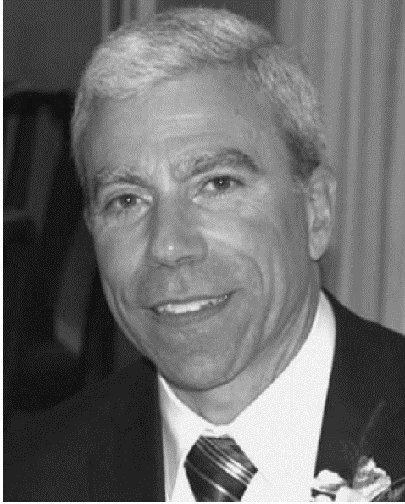

Dr. Paul C. Hershey received the A.B. degree in mathematics from the College of William and Mary, Williamsburg, VA, USA, and the Ph.D. and M.S. degrees in electrical engineering from the University of Maryland, College Park, MD, USA. His Ph.D. research, sponsored by IBM, created a near-real-time information collection, analysis, and decision system that resulted in direct customer sales. Dr. Hershey’s 35 years of electrical engineering research and development experience encompasses work with technology producers, service providers, government contractors, start-up companies, and universities, thereby equipping him with a rich background from which he has derived, assessed, and realized innovative engineering solutions.  He is currently a Senior Engineering Fellow (with honors) at Raytheon Intelligence, Information and Services, Dulles, VA, where his work focuses on data analytics, autonomous systems, cloud computing, and cyber security. He has published 29 patents (issued), 10 patents (filed), and 49 peer-reviewed technical papers.  Dr. Hershey is an Adjunct Professor with George Washington University, Washington, DC, where he serves on the Curriculum Advisory Board.  He is an IEEE Senior Member and serves on the technical program committees for the IEEE International Systems Conference (also on the conference steering committee), the IEEE International Systems of Systems Engineering Conference (an industrial liaison), and the IEEE Military Communications Conference (MILCOM).

|  |
| --- |
| **Daniel DeLarentis** Professor  Department of Aerospace Engineering  Purdue University |

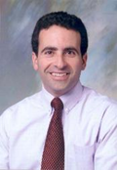

Dr. Daniel DeLaurentis is an Associate Professor in Purdue’s School of Aeronautics & Astronautics. He leads Purdue's Center for Integrated Systems in Aerospace (CISA), which is home to 20 faculty affiliates, three research staff, and numerous dedicated graduate students. He also leads the ISA Center's largest recent project with the Missile Defense Agency's Enhanced C2BMC program developing agent-based modeling and simulation for development of advanced battle management architectures. His research is conducted under grants from NASA, FAA, Navy, the DoD Systems Engineering Research Center UARC, and the Missile Defense Agency. Dr. DeLaurentis is an Associate Fellow of the American Institute of Aeronautics and Astronautics and served as Chairman of the AIAA’s Air Transportation Systems Technical Committee from 2008-2010. He is also AIAA Deputy Strategic Technologies Coordinator since 2011. He is also Co-Chair of the System of Systems Technical Committee in the IEEE System, Man, and Cybernetics Community and is Associate Editor for the IEEE Systems Journal. Dr. DeLaurentis is Fellow of Purdue’s Center for Education and Research in Information Assurance and Security, 2012. He received his Ph.D. in Aerospace Engineering from the Georgia Institute of Technology in 1998.

|  |
| --- |
| **Russell L. (Rusty) Roberts** Director Aerospace, Transportation & Advanced Systems Lab  Georgia Tech Research Institute |

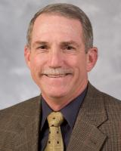

Dr. Russell L. (Rusty) Roberts began his career at GTRI working in the Cobb County Research Facility in 1988. Since January 2009, he has been the director of GTRI's Aerospace, Transportation and Advanced Systems (ATAS) laboratory, one of two units headquartered at the Cobb facility near Dobbins Air Reserve Base. Previously, Roberts served for eight years as the associate director for business development in GTRI's Information Technology and Telecommunications Laboratory, and 12 years as program manager in the Systems Development Laboratory which was merged to create ATAS. He was also an officer in the U.S. Army Signal Corps for ten years.

|  |
| --- |
| **Sandra Begay-Campbell**   technical assistance program   Sandia National Laboratories’ tribal energy |

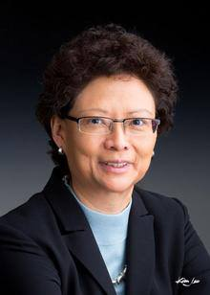

Sandra Begay-Campbell is a Principal Member of the Technical Staff at Sandia National Laboratories and is a former Regent (Trustee) for the University of New Mexico. Sandra leads Sandia’s technical efforts to assist Native American tribes with their renewable energy developments. Sandra received a Bachelor of Science - Civil Engineering degree from the University of New Mexico. She worked at Lawrence Livermore National Laboratories before she earned a Master of Science - Structural Engineering degree from Stanford University. Sandra is recognized in a book profiling women engineers, “Changing Our World: True Stories of Women Engineers." Begay-Campbell is included in the chapter "Women in Power", which describes her effort to provide electricity through solar panels and other alternative energy solutions to hundreds of remote tribal members on the Navajo Reservation. Honored with awards for her work, Sandra is a recent recipient of the American Indian Science and Engineering Society’s Life-time Achievement Award; the University of New Mexico’s 2007 Zia Alumnus Award; the 2005 UNM School of Engineering Distinguished Alumnus Award and she received the Stanford University 2000 Multicultural Alumni of the Year Award. She was also selected as a recipient of the Governor's Award for Outstanding Women from the New Mexico Commission on the Status of Women.

|  |
| --- |
| **Alton S. Wallace**  Senior Independent Research Consultant |

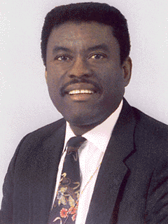

Dr. Alton Wallace has a B.S. in engineering mathematics from North Carolina A&T State University, an M.S. in mathematics from Pennsylvania State University, and a Ph.D. in mathematics from University of Maryland (1974). He has over 40 years of operational test experience, working initially for System Planning Corporation (SPC), supporting Army, Navy, and Air Force programs, and later for the Institute for Defense Analyses (IDA), supporting Army programs. Dr. Wallace develops test concepts, design specific tests, and conducts the required data analyses to insure weapons are adequately tested to support acquisition decisions.  These tests explore all aspects of system performance when used by soldiers to include stressing the performance envelope, training, logistics, operating in jamming environments and cyber security. The range of systems tested include remotely piloted air vehicles, robotic ground vehicles, communications systems, military ground vehicles, and tactical and ballistic missiles.

|  |
| --- |
| **Julius Yellowhair**   Senior Member of the Technical Staff   Sandia National Laboratories |

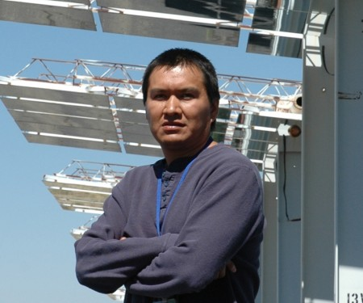

Dr. Julius Yellowhair (Navajo), PhD, graduated with his PhD from the University of Arizona in 2007. He is currently an optical engineer and a Senior Member of the Technical Staff at Sandia National Laboratories.

|  |
| --- |
| **Mark Noakes**  Senior R&D Staff, Robotics and Remote Systems  Oak Ridge National Laboratory |

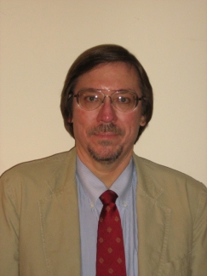

Mark W Noakes, BS/MS/PE Electrical Engineering, PhD Mechanical Engineering, is a senior R&D staff member in the Remote Systems Group at the Oak Ridge National Laboratory, and also Adjunct Professor, Mechanical Engineering, at the University of Tennessee at Knoxville. His areas of interest and expertise include robotics & remote systems (force-reflecting tele operated and tele robotic manipulation), mechatronics, instrumentation and controls, additive manufacturing/3D printing, mentoring engineering students, and participating in local STEM activities to encourage grade school and high school students to pursue technical careers. Past research sponsors include the Department of Energy’s Robotics Technology Development Program and Robotics Crosscutting Program (primarily decontamination and decommissioning (D&D) of contaminated nuclear facilities), DARPA (Trauma Pod remote surgery), and ONR (Bluefin manipulators). Noakes has also participated in International Atomic Energy Agency/US State Department training courses in robotics and remote systems for nuclear D&D. Noakes is a member of IEEE, SAE, ASME, and is a past chair of the American Nuclear Society Robotics and Remote Systems Division. Noakes has more than 60 publications consisting of conference papers, journal articles, and reports.

|  |
| --- |
| **Richard Carreras**   Physics Base, Modeling and Simulation Section   Air Force Research Laboratory (AFRL) |

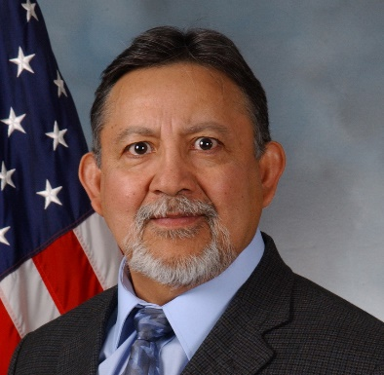

Richard received his B.S. in Electrical Engineering from New Mexico State University (NMSU) in 1976, and his M.S.E in Electro-Optics from Arizona State University (ASU) at Tempe Arizona in 1980. He received an MBA from New Mexico Highland University (NMHU) in 1986 and his PhD in Linear Systems Theory from University of New Mexico in 1994. After graduating from NMSU as an Electrical Engineer, he moved to Phoenix, Arizona metropolitan and worked for Motorola. Shortly after graduating from ASU, he moved to the Air Force Research Laboratory (AFRL) at Kirtland Air Force Base, in Albuquerque, New Mexico and proceeded with his research in optics and lasers. Dr. Carreras has held numerous positions at the AFRL and is currently the Principle Investigator for the Physics Base, Modeling and Simulation Section. Dr. Carreras has presented many papers at Technical Conferences and chaired Technical Sessions. He also organized and ran the entire Technical Conferences for SPIE (an international society for optics and photonics), WAC (World Automation Congress), and the DEPS (Directed Energy Professional Society). Dr. Carreras was honored as a Fellow in SPIE in 2008.

|  |
| --- |
| **Bijan Sayyarrodsari**  Manager - Research & Development Center  Strategic Development  Rockwell Automation |

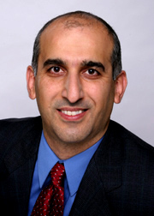

Dr. Bijan Sayyarrodsari manages Rockwell’s research and development center that focuses on advanced model-based analytics in support of Rockwell Automation’s business units worldwide. He received his Ph.D. degree in Electrical Engineering from Stanford University in 1999. He has been involved in design, development, and field testing of advanced performance monitoring, control, and optimization solutions in a wide-range of industrial applications for more than 15 years. His primary interests focus on data-driven, self-learning analytics engines with applications in diagnostics and integrated optimization and control for manufacturing industry.